Maternal and Child Health Council Data Review and Sensemaking

Perinatal and Infant Group
Date: 1/11/23 Recorder:

Participants:

Infant Mortality Patterns and Possible Factors

Evaluation Question(s) Addressed
- What is the pattern in infant mortality over time?
- What factors or conditions may have contributed to this pattern?

Specific Graph/Evaluation Data Reviewed
NOM 9_1 Infant mortality rate per 1,000 live births (Medicaid, Non-Medicaid, and All)
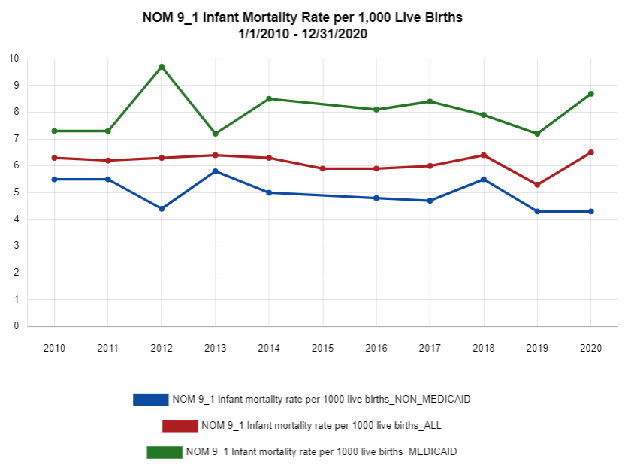

What are we seeing in the data [e.g., What was the pattern of infant mortality over time? Where were there increases in levels? Decreases? What pattern did the group intend/expect, and did they meet it?]:
- Indicate where higher levels, and what was associated:
- Indicate where lower levels, and what was associated:
- Indicate where there are disparities in levels:
- Indicate whether this was the pattern the group intended/expected:

What it means: [What factors were associated with increased/higher levels?; What factors were associated with decreased/lower levels? What factors are associated with disparities?]
- Factors associated with increased/higher levels:
- Factors associated with decreased/lower levels:
- Factors associated with disparities:

Implications for adjustment:
[What adjustments (if any) should we make to improve activities and outcomes?]:
- Indicate adjustments the group should/will make to improve outcomes and reduce disparities

--ACTION PLAN for Improvement (indicate goal):
WHAT will be done | BY WHOM | BY WHEN | RESOURCES NEEDED

